Latin Preposition Worksheet

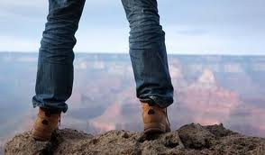 |  |  |  | 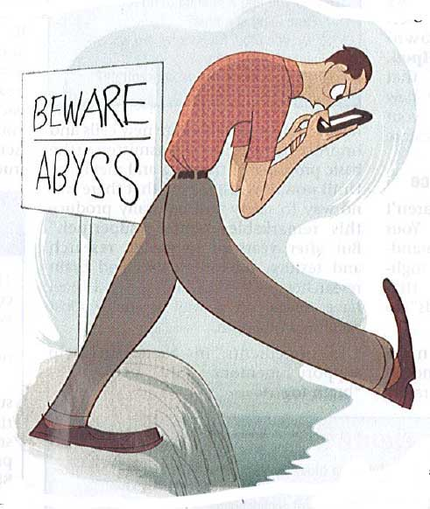
 | Nom. | terra | terrae |  | Nom. | abyssus | abyssi
 | Gen. | terrae | terrarum |  | Gen. | abyssi | abyssorum
 | Dat. | terrae | terris |  | Dat. | abysso | abyssis
On the Ground  ________________ | Acc. | terram | terras | Over the abyss  ____________ | Acc. | abyssum | abyssos
On the Ground  ________________ | Abl. | terra | terris | Over the abyss  ____________ | Abl. | abysso | abyssis
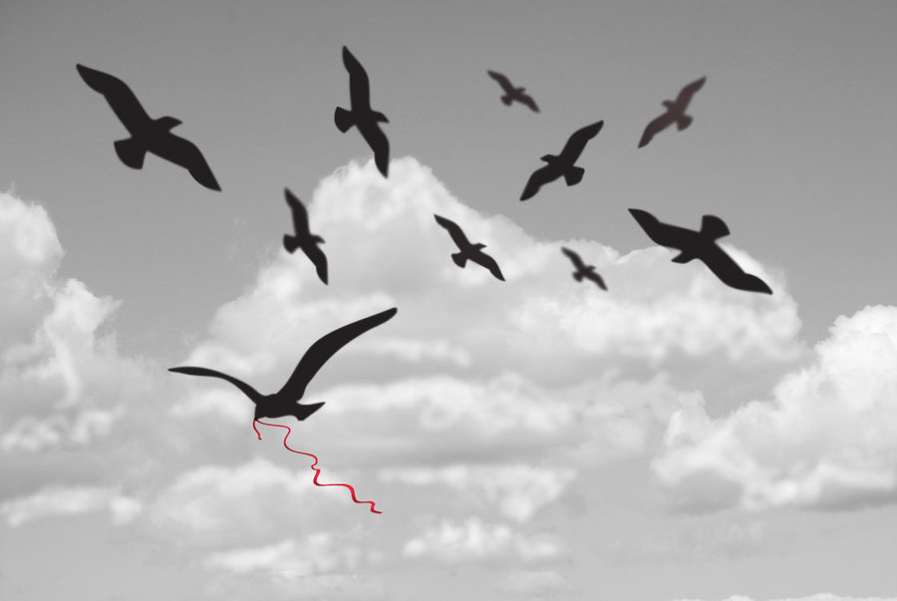 |  |  |  | 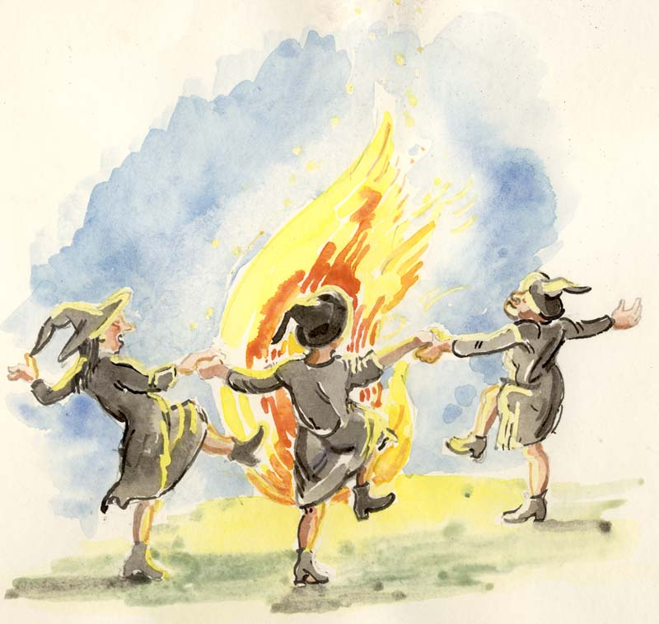
 | Nom. | caelum | caela |  | Nom. | ignis | ignes
 | Gen. | caeli | caelorum |  | Gen. | ignis | ignium
 | Dat. | caelo | caelis |  | Dat. | igni | ignibus
In the sky  ________________ | Acc. | caelum | caela | Around the fire  ____________ | Acc. | ignem | ignes
In the sky  ________________ | Abl. | caelo | caelis | Around the fire  ____________ | Abl. | igne | ignibus
 |  |  |  | 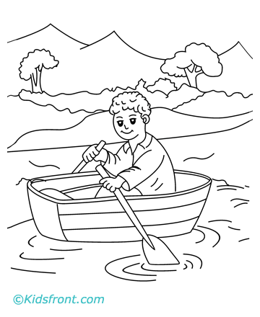
 | Nom. | tenebra | tenebrae |  | Nom. | navis | naves
 | Gen. | tenebrae | tenebrarum |  | Gen. | navis | navium
 | Dat. | tenebrae | tenebris |  | Dat. | navi | navibus
In the darkness  ________________ | Acc. | tenebram | tenebras | In the boat  ____________ | Acc. | navem | naves
In the darkness  ________________ | Abl. | tenebra | tenebris | In the boat  ____________ | Abl. | nave | navibus
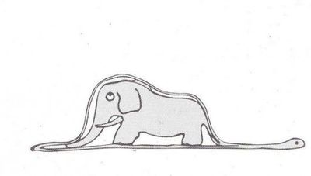 |  |  |  | 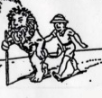
 | Nom. | serpens | serpentes |  | Nom. | leo | leones
 | Gen. | serpentis | serpentum |  | Gen. | leonis | leonum
 | Dat. | serpenti | serpentibus |  | Dat. | leoni | leonibus
Inside the serpent  ________________ | Acc. | serpentem | serpentes | With the lion  ____________ | Acc. | leonem | leones
Inside the serpent  ________________ | Abl. | serpente | serpentibus | With the lion  ____________ | Abl. | leone | leonibus
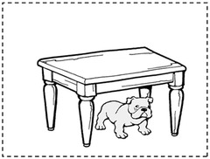 |  |  |  | 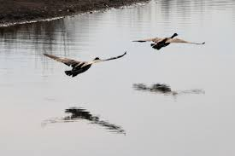
 | Nom. | mensa | mensae |  | Nom. | aqua | aquae
 | Gen. | mensae | mensarum |  | Gen. | aquae | aquarum
 | Dat. | mensae | mensis |  | Dat. | aquae | aquis
Under the table  ________________ | Acc. | mensam | mensas | Over the water  ____________ | Acc. | aquam | aquas
Under the table  ________________ | Abl. | mensa | mensis | Over the water  ____________ | Abl. | aqua | aquis
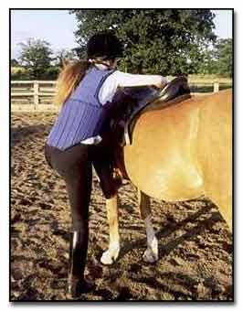 |  |  |  | 
 | Nom. | equus | equi |  | Nom. | collis | colles
 | Gen. | equi | equorum |  | Gen. | collis | collium
 | Dat. | equo | equis |  | Dat. | colli | collibus
Onto the horse  ________________ | Acc. | equum | equos | On the hill  ____________ | Acc. | collem | colles
Onto the horse  ________________ | Abl. | equo | equis | On the hill  ____________ | Abl. | colle | collibus

