Historia ecclesiastica gentis anglorum – Bede
Liber primus, Caput secundum

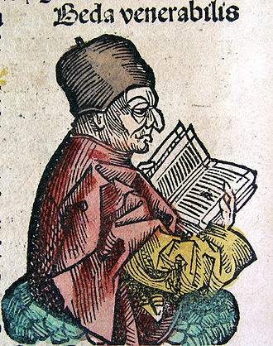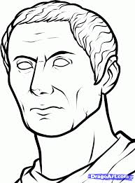

II. Ut Brittaniam primus Romanorum Gaius Iulius adierit.

Chap. II. How Caius Julius Caesar was the first Roman that came into Britain.

Uerum eadem Brittania Romanis usque ad Gaium Iulium Caesarem inaccessa atque incognita fuit; qui anno ab Urbe condita DCXCIII, ante uero incarnationis dominicae tempus anno LXmo, functus gradu consulatus cum Lucio Bibulo,
dum contra Gallorumque gentes, qui Hreno tantum flumine dirimebantur, bellum gereret, uenit ad Morianos, unde in Brittaniam proximus et breuissimus transitus est;
et nauibus honerariis atque actuariis circiter octoginta praeparatis, in Brittaniam transuehitur, ubi acerba primum pugna fatigatus, deinde aduersa tempestate correptus, plurimam classis partem, et non paruum numerum militum, equitum uero pene omnem disperdidit.

Now Britain had never been visited by the Romans, and was entirely unknown to them before the time of Caius Julius Caesar, who, in the year 693 after the foundation of Rome, but the sixtieth year33 before the Incarnation of our Lord, was consul with Lucius Bibulus.
While he was making war upon the Germans and the Gauls, who were divided only by the river Rhine, he came into the province of the Morini, whence is the nearest and shortest passage into Britain.
Here, having provided about eighty ships of burden and fast-sailing vessels, he sailed over into Britain; where, being first roughly handled in a battle, and then caught in a storm, he lost a considerable part of his fleet, no small number of foot-soldiers, and almost all his cavalry.

Regressus in Galliam, legiones in hiberna dimisit, ac DCtas naues utriusque commodi fieri imperauit;
quibus iterum in Brittaniam primo uere transuectus, dum ipse in hostem cum exercitu pergit, naues in anchoris stantes tempestate correptae uel conlisae inter se, uel arenis inlisae ac dissolutae sunt; ex quibus XL perierunt, ceterae cum magna difficultate reparatae sunt.

Caesaris equitatus primo congressu a Brittanis uictus, ibique Labienus tribunus occisus est.

Returning into Gaul, he put his legions into winter-quarters, and gave orders for building six hundred sail of both sorts.
With these he again crossed over early in spring into Britain, but, whilst he was marching with the army against the enemy, the ships, riding at anchor, were caught in a storm and either dashed one against another, or driven upon the sands and wrecked.
Forty of them were lost, the rest were, with much difficulty, repaired.
Caesar's cavalry was, at the first encounter, defeated by the Britons, and there Labienus, the tribune, was slain.

Secundo proelio cum magno suorum discriminc uictos Brittanos in fugam uertit. Inde ad flumen Tamensim profectus.
In huius ulteriore ripa Cassobellauno duce inmensa hostium multitudo consederat, ripamque fluminis ac pene totum sub aqua uadum acutissimis sudibus praestruxerat;
quarum uestigia sudium ibidem usque hodie uisuntur, et uidetur inspectantibus, quod singulae earum ad modum humani femoris grossae, et circumfusae plumbo inmobiliter erant in profundum fluminis infixae.

In the second engagement, with great hazard to his men, he defeated the Britons and put them to flight. Thence he proceeded to the river Thames, where a great multitude of the enemy had posted themselves on the farther side of the river, under the command of Cassobellaunus, and fenced the bank of the river and almost all the ford under water with sharp stakes: the remains of these are to be seen to this day, apparently about the thickness of a man's thigh, cased with lead, and fixed immovably in the bottom of the river.

Quod ubi a Romanis deprehensum ac uitatum est, barbari legionum impetum non ferentes, siluis sese abdidere, unde crebris eruptionibus Romanos grauiter ac saepe lacerabant.
Interea Trinouantum firmissima ciuitas cum Androgio duce, datis XL obsidibus, Caesari sese dedit.
Quod exemplum secutae, urbes aliae conplures in foedus Romanorum uenerunt. Hisdem demonstrantibus, Caesar oppidum Cassobellauni inter duas paludes situm, obtentu insuper siluarum munitum, omnibusque rebus confertissimum tandem graui pugna cepit.
Exin Caesar a Brittanis reuersus in Galliam, postquam legiones in hiberna misit, repentinis bellorum tumultibus undique circumuentus et conflictatus est.

This being perceived and avoided by the Romans, the barbarians, not able to stand the charge of the legions, hid themselves in the woods, whence they grievously harassed the Romans with repeated sallies.
In the meantime, the strong state of the Trinovantes, with their commander Androgius, surrendered to Caesar, giving him forty hostages.
Many other cities, following their example, made a treaty with the Romans.
Guided by them, Caesar at length, after severe fighting, took the town of Cassobellaunus, situated between two marshes, fortified by sheltering woods, and plentifully furnished with all necessaries.

After this, Caesar returned from Britain into Gaul, but he had no sooner put his legions into winter quarters, than he was suddenly beset and distracted with wars and sudden risings on every side.

